“MIRCEA CEL BATRAN” NAVAL ACADEMY
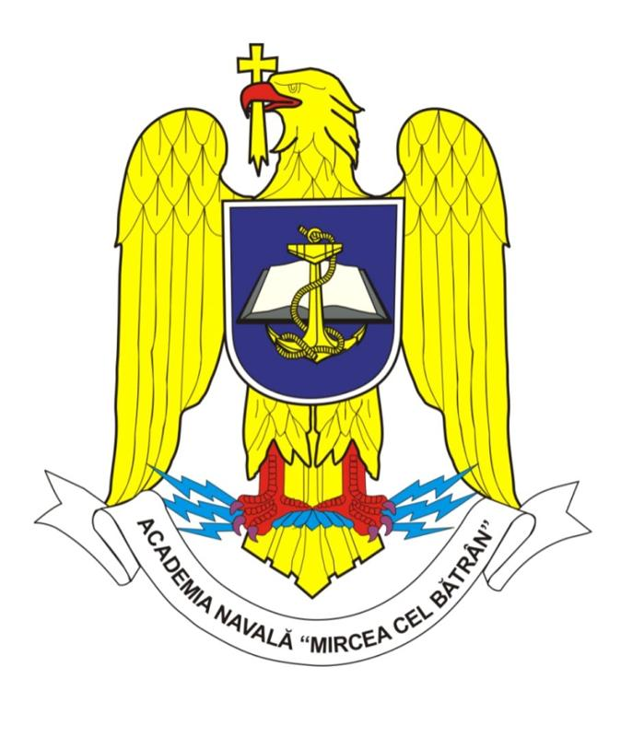
No 1 Fulgerului St., 900218, Constanta, Romania
Phone: +40-241626200, fax: +40-241626200, e-mail: sailingtothefuture@anmb.ro

Naval technique and didactic equipment exhibition for naval education.
„SAILING TO THE FUTURE”
The exhibition displays naval equipment, navigation equipment and instruments, teaching aids for naval education, specialized programs, books and specialized maritime journals,sports and pleasure boats, equipment dedicated to the maritime field, college and higher maritime education, programs and results of the research-development-innovation activities.
May 17th until 19th, 2019, No.1 Fulgerului St., Constanta, Romania
CONTRACT-AGREEMENT
Company/Institution..........................................................Reprezentative …………..........................................
Address.....................................................................................................................................................
Phone................................................Fax........................................Email.............................................
Contact person...........................................................................Phone...............................................
COMPANY PRESENTATION  ...........................................................................  Presentation of exhibits  ............................................................................. | FEES AND SERVICES  Registration fee: no registration fee.  Limited number of stands.  The indoor stand is fitted with a table, chairs,and a 220V plug.  The outdoor stand is displayed on the paved premises of the institution, the access to which is ensured from the check point.  We ensure:  - Acces to toilets  - Contact person  - Meal paid by the visitors  - Necessary information about accommodation in town.  Information about the company and the exhibits will be included in the Exhibition Brochure, which will be available for the visitors.  We agree on the participating conditions which are part of this present Contract-Agreement, thereof we sign.
Organizer:  Rector,  Commander, Eng. PhD Octavian Tărăbuţă | Exhibitor:  Director,
Participating Conditions
at the Naval technique and didactic equipment exhibition for naval education.
„SAILING TO THE FUTURE”
At the „SAILING TO THE FUTURE”exhibition, organized by „Mircea cel Batran” Naval Academy, between May 17th until 19th, 2019, at No.1 Fulgerului St, Constanta, Romania, may participate any Romanian or foreign company or institution, working in the naval or maritime field, interested to display their exhibits.
- ”Mircea cel Batran” Naval Academy will ensure the exhibitors all the conditions stipulated in the present Contract-Agreement.
- ”Mircea cel Batran” Naval Academy will inform all the participants on the safety work rules as well as on the fire-fighting ones.
- The exhibitors will comply with the above regulations.
- The exhibitors will inform the „Mircea cel Batran” Naval Academy organizer about the persons that are part of their team.
- „Mircea cel Batran” Naval Academy complies with the UE 2016-679 provisons with regard to data protection and processing of personal data and the free circulation thereof.
- Any problem will be amiably solved between the two parties.

