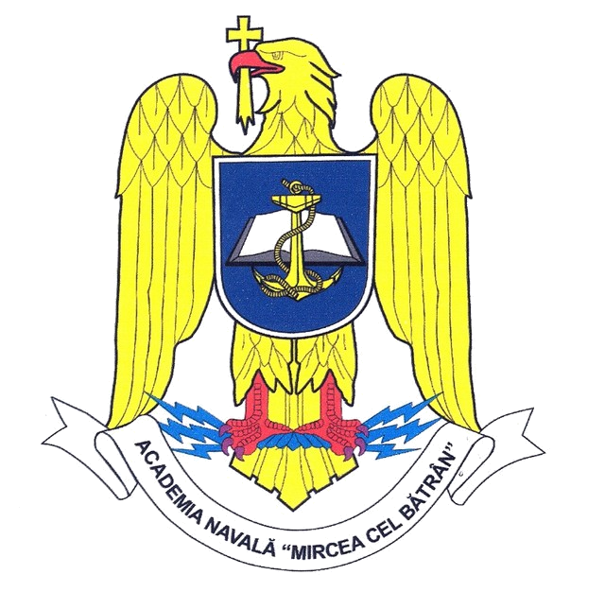  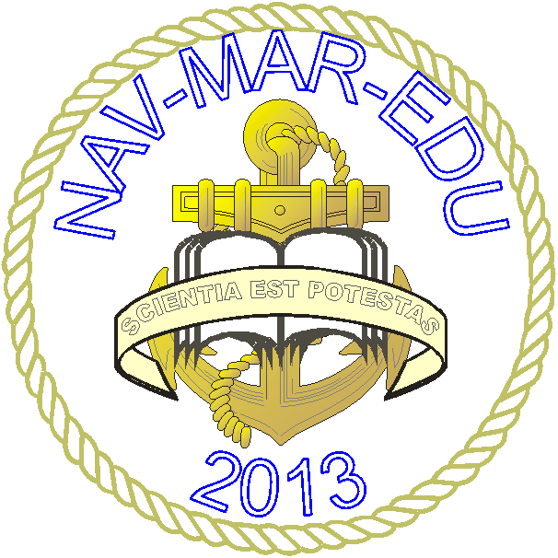 | The International Conference  NAV-MAR-EDU 2013  May 30th –June 01st, 2013  Constanta, Romania

REGISTRATION FORM
Last/first Name (with title)
Name of the Institution/Organization
Country
Passport/Identity card (serial/number)
Contact details
Mailing address:
Phone:
Fax:
E-mail:
Title of the paper:
Section: | 1. Electrical engineering
Section: | 2. Mechanical engineering
Section: | 3. Informatics and mathematical science
Section: | 4. Military and nautical sciences
Section: | 5. Humanities sciences
Section: | 6. Economic sciences
Section: | 7. Foreign languages
Abstract (200 words max). Allowed extensions =.doc, .docx

Accommodation Booking Request:
I want MBNA to provide me accommodation, at a 2*; 3*; 4* single room/ double room hotel
I have chosen some other type of accommodation
Travel Information |  | Date of Arrival | Date of Departure
I wish to attend:
Cruise on the the Black Sea with „Mircea” School Ship
Please be so kind and send the completed registration form to the Organizing Committee by email (navmaredu@anmb.ro).

