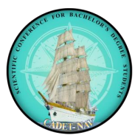 |  | CADET-NAV  International Students’ Scientific Conference  Romanian Naval Academy,  CONSTANTA/ROMANIA  23rd – 25th of April 2026  Application form | 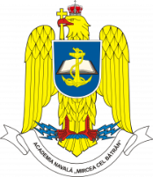
COUNTRY
UNIVERSITY
POC:
Email:
Phone number
Attendees:
1 | Military / Civilian |  | Title |  | Sex |  |  | Date of birth  DD/MM/YY |  |  | ID/Passport  number
1 | M C |  |  |  | F M
1 | Name (first / last)
2 | Military / Civilian |  | Title |  | Sex |  |  |  | Date of birth  DD/MM/YY |  | ID/Passport  number
2 | M C |  |  |  | F M
2 | Name (first / last)
3 | Military / Civilian |  | Title |  | Sex |  |  |  | Date of birth  DD/MM/YY |  | ID/Passport  number
3 | M C |  |  |  | F M
3 | Name (first / last)
ITINERARY
Arrival |  | Plane Bus Personal Car Other
Date / Hour
Airport
Departure |  | Plane Bus Personal Car Other
Date / Hour
Airport
ACCOMMODATION FORM – to be booked individually or by the organizer
23/04/2026 to 24/04/2026 |  |  |  | YES NO |  |  | RNA Dormitory
24/04/2026 to 25/04/2026 |  |  |  | YES NO
25/04/2026 to 26/04/2026 |  |  |  | YES NO
SPECIAL REQUESTS & QUESTIONS

Remarks:
- The flight details will be extended once available.

Upon completion submit the final form to RNA PoC: Commander Marius CUCU, emails: cadetnav@anmb.ro; international@anmb.ro

