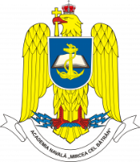 |  | “CADET-NAV – International Students’ Scientific Conference”  Romanian Naval Academy,  CONSTANTA/ROMANIA  08th – 10th of May 2025  Application form | 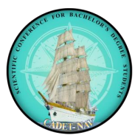
COUNTRY
UNIVERSITY
POC:
Email:
Phone number
Attendees:
1 | Military / Civilian |  | Title |  | Sex |  |  | Date of birth  DD/MM/YY |  |  | ID/Passport  number
1 | M C |  |  |  | F M
1 | Name (first / last)
2 | Military / Civilian |  | Title |  | Sex |  |  |  | Date of birth  DD/MM/YY |  | ID/Passport  number
2 | M C |  |  |  | F M
2 | Name (first / last)
3 | Military / Civilian |  | Title |  | Sex |  |  |  | Date of birth  DD/MM/YY |  | ID/Passport  number
3 | M C |  |  |  | F M
3 | Name (first / last)
ITINERARY
Arrival |  | Plane Bus Personal Car Other
Date / Hour
Airport
Departure |  | Plane Bus Personal Car Other
Date / Hour
Airport
ACCOMMODATION FORM – to be booked individually or by the organizer
08/05/2025 to 08/05/2025 |  |  |  | YES NO |  |  | Hostel of MBNA or  optional hotel
08/05/2025 to 09/05/2025 |  |  |  | YES NO
09/05/2025 to 10/05/2025 |  |  |  | YES NO
SPECIAL REQUESTS & QUESTIONS

Remarks:
- The flight details will be extended once available.

Upon completion submit the final form to MBNA PoC: Capt. Clinci Catalin, cadetnav@anmb.ro

