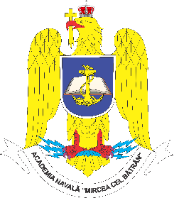 | ROMANIAN NAVAL ACADEMY  1st Fulgerului street, 900218, Constanta, Romania  Tel/fax: +40241/643096  Email: rectorat@anmb.ro | 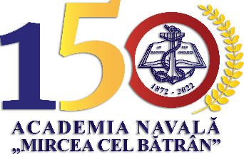

CADET-NAV 2022

07th of April – 08th of April 2022
Constanta, Romania

CONFERENCE REGISTRATION FORM

Name, surname:
Coordinator:
Institution:
Country:
Paper title (in English language):
Section: | 1. Navigation and Transport;
Section: | 2. Engineering and Management;
Section: | 3. Military Sciences and Information;
Section: | 4. Electrical Engineering;
Section: | 5. Weapons and Communications;
Section: | 6. Mechanical Engineering;
Section: | 7. Fundamental Sciences.
Abstract:

Requirements for presentation:

Accommodation request:
Special meals request (dietary, if the case): |  | YES € | NO 
Vaccination status: |  | YES  | NO €
Transportation details:  Airport location (flight details): |  | Date of arrival: | Date of departure:

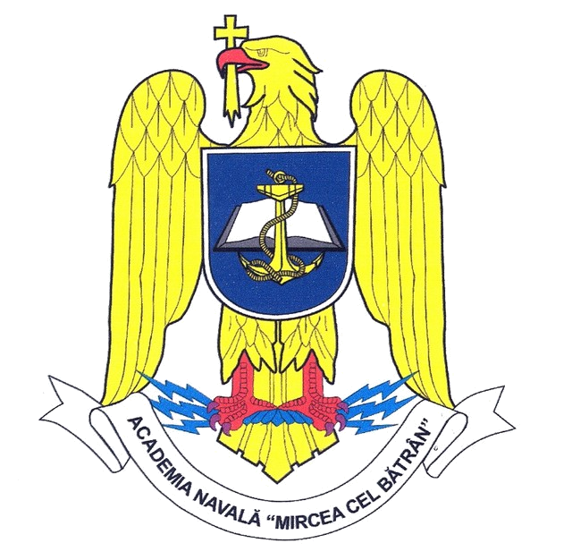
Please complete this form and send it to the Organizing Committee by email at cadetnav@anmb.ro, by 31st of March 2022, the latest.

