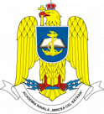 | ROMANIAN NAVAL ACADEMY “MIRCEA CEL BĂTRÂN”  Erasmus+ Office  Str. Fulgerului, nr.1, 900218, tel/fax. 0241-643096,  e-mail. erasmus@anmb.ro | 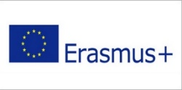
PARTICIPANT REPORT – STUDENT MOBILITY FOR STUDIES
First and last name
University
Faculty/Department
Study Semester
Mobility period | Start date: End date:
- How did you find out about the Romanian Naval Academy „Mircea cel Batran” ?
from former students who participated in Erasmus+;
from our Erasmus+ Institutional Coordinator;
online;
other (specify) ....................................................................................................
- How do you consider that your study mobility was:
too long;
too short;
enought.
- Are you planning to take part in Erasmus+ mobility again in RNA?
YES;
NO;
Don’t know;
- Would you recommend this experience to another student?
YES;
NO;
Don’t know;

- How satisfied were you with the support provided by your receiving institution ? 1 – unsatisfactory, 5 – excelent.
Administrative support arrangements 1 - 2 - 3 - 4 - 5
Academic mentoring 1 - 2 - 3 - 4 - 5
Support from student initiatives 1 - 2 - 3 - 4 - 5
Help with personal needs and porblems 1 - 2 - 3 - 4 - 5
The quality of content of courses/teaching methods 1 - 2 - 3 - 4 - 5
How satisfied are you with the mobility in general ? 1 - 2 - 3 - 4 - 5

- How do you think the Erasmus + program could be improved?

- Describe your experience.

Date: _________________ Signature________________

